AKGEC/IAP/FM/02
Ajay Kumar Garg Engineering College, Ghaziabad
Department of Applied Sciences & Humanities
Sessional Test-2
Course: B.Tech Semester: III
Session: 2017-18 Section: EC1, EC2, EC3, ME1,
ME2, ME3, CE-1, CE2
Subject: ENGG. MATHEMATICS-III Sub. Code: RAS-301
Max Marks: 50 Time: 2 hour

NOTE: Answer all the sections
SECTION-A
A. Attempt all the parts. (5*2=10)
1. Define correlation and regression analysis.
2. Obtain the MGF of random variable x having probability distribution f(x)= 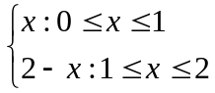
3. Find Z-transform of 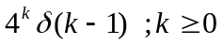.
4. Find 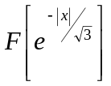.
5. Prove that 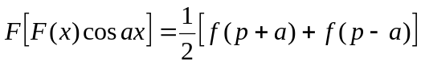.
SECTION-B
B. Attempt all the parts. (5*5=25)
6. The first four moments of a distribution about the value ‘0’ are -0.20, 1.76, -2.36 and 10.88 . Find the moments about mean and discuss the kurtosis, skewness.
7. The regression lines of y on x and x on y respectively are y=ax+b and x= cy+d.
Show that 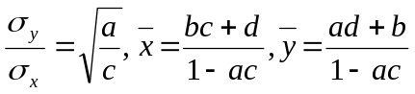.
8. If the heights of 300 students are normally distributed with mean 64.5 inches and standard deviation 3.3 inches,
find the height below which 99% of the students lie.
.
9. Solve by Z-transform the difference equation: 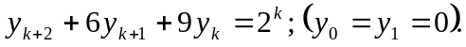
10. Using convolution theorem, evaluate 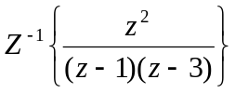
SECTION-C
C. Attempt all the parts. (2*7.5=15)
11. . Obtain the least squares fit of the form f(t)= 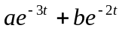 for the data:
t : 0.1 0.2 0.3 0.4
f(t) : 0.76 0.58 0.44 0.35
12. The temperature u in the semi-infinite rod 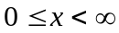 is determined by the differential equation 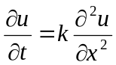
subject to the conditions; (i) u=0 when t=0, 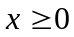
(ii) 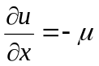 (which is a constant) when x=0 and t>0. Making use of cosine transform, show that
